ESP32-CAM Module

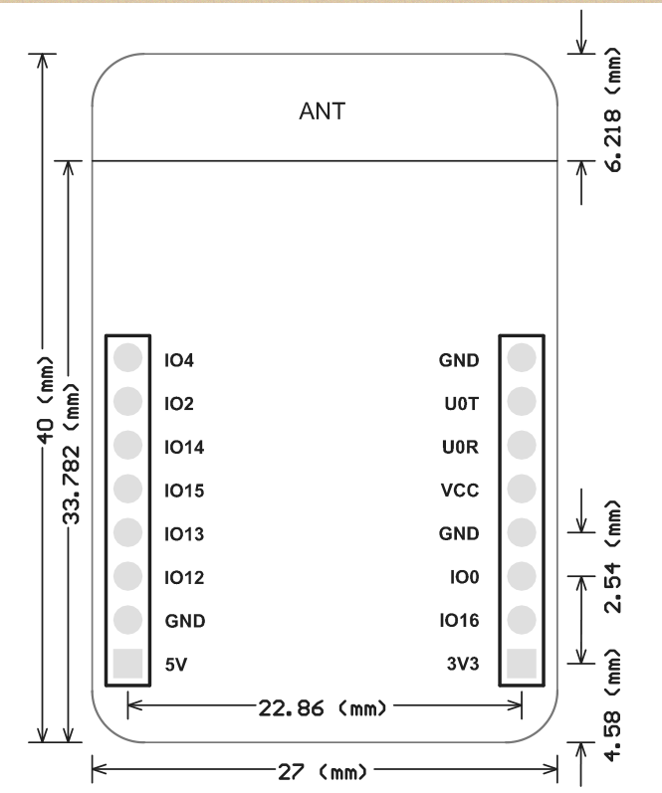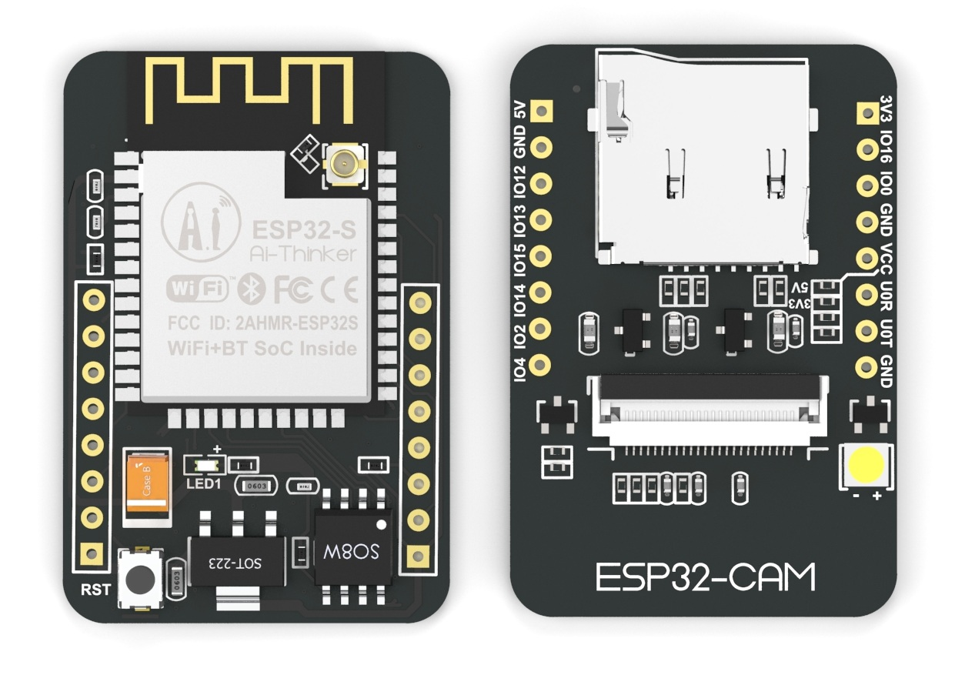
Overview
Features

The ESP32-CAM has a very competitive small-size camera module that can operate independently as a minimum system with a footprint of only 27*40.5*4.5mm and a deep sleep current of up to 6mA.
ESP-32CAM can be widely used in various IoT applications. It is suitable for home smart devices, industrial wireless control, wireless monitoring, QR wireless identification, wireless positioning system signals and other IoT applications. It is an ideal solution for IoT applications.
ESP-32CAM adopts DIP package and can be directly inserted into the backplane to realize rapid production of products, providing customers with high-reliability connection mode, which is convenient for application in various IoT hardware terminals.

- The smallest 802.11b/g/n Wi-Fi BT SoC Module
- Low power 32-bit CPU,can also serve the
application processor
- Up to 160MHz clock speed，Summary
computing power up to 600 DMIPS
- Built-in 520 KB SRAM, external 4MPSRAM
- Supports UART/SPI/I2C/PWM/ADC/DAC
- Support OV2640 and OV7670 cameras,Built-in
Flash lamp.
- Support image WiFI upload
- Support TF card
- Supports multiple sleep modes.
- Embedded Lwip and FreeRTOS
- Supports STA/AP/STA+AP operation mode
- Support Smart Config/AirKiss technology
- Support for serial port local and remote firmware
upgrades (FOTA)

Product Specifications

Module Model | ESP32-CAM
Package | DIP-16
Size | 27*40.5*4.5（±0.2）mm
SPI Flash | Default 32Mbit
RAM | 520KB SRAM +4M PSRAM
Bluetooth | Bluetooth 4.2 BR/EDR and BLE standards
Wi-Fi | 802.11 b/g/n/
Support interface | UART、SPI、I2C、PWM
Support TF card | Maximum support 4G
IO port | 9
UART Baudrate | Default 115200 bps
Image Output Format | JPEG( OV2640 support only ),BMP,GRAYSCALE
Spectrum Range | 2412 ~2484MHz
Antenna | Onboard PCB antenna, gain 2dBi
Transmit Power | 802.11b: 17±2 dBm (@11Mbps)  802.11g: 14±2 dBm (@54Mbps)  802.11n: 13±2 dBm (@MCS7)
Receiving Sensitivity | CCK, 1 Mbps : -90dBm  CCK, 11 Mbps: -85dBm  6 Mbps (1/2 BPSK): -88dBm  54 Mbps (3/4 64-QAM): -70dBm  MCS7 (65 Mbps, 72.2 Mbps): -67dBm
Power Dissipation | Turn off the flash lamp:180mA@5V  Turn on the flash lamp and turn on the brightness to the maximum:310mA@5V  Deep-sleep: Minimum power consumption can be achieved 6mA@5V  Moderm-sleep: Minimum up to 20mA@5V  Light-sleep: Minimum up to 6.7mA@5V
Security | WPA/WPA2/WPA2-Enterprise/WPS
Power Supply Range | 5V
Operating Temperature | -20 ℃ ~ 85 ℃
Storage Environment | -40 ℃ ~ 90 ℃ , < 90%RH
Weight | 10g
ESP32-CAM module picture output format rate

ESP32-CAM模块图片输出格式速率
Format Size | QQVGA | QVGA | VGA | SVGA
JPEG | 6 | 7 | 7 | 8
BMP | 9 | 9 | - | -
GRAYSCALE | 9 | 8 | - | -
Internal Pin Connect

CAM | ESP32 | SD | ESP32
D0 | PIN5 | CLK | PIN14
D1 | PIN18 | CMD | PIN15
D2 | PIN19 | DATA0 | PIN2
D3 | PIN21 | DATA1/Flash lamp | PIN4
D4 | PIN36 | DATA2 | PIN12
D5 | PIN39 | DATA3 | PIN13
D6 | PIN34
D7 | PIN35
XCLK | PIN0
PCLK | PIN22
VSYNC | PIN25
HREF | PIN23
SDA | PIN26
SCL | PIN27
POWER PIN | PIN32

Minimum system diagram
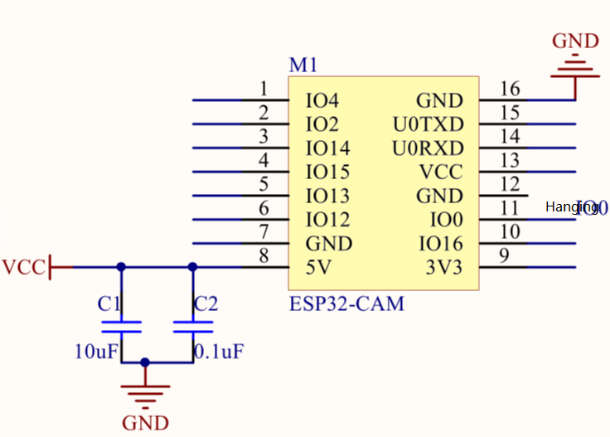

Contact US

Shenzhen Ai-Thinker Technology Co., Ltd
Address: 7/F, Fengze Building B, Huafeng Industrial Park 2th, Hangkong street,Xixiang Raod, Baoan, Shenzhen China
Website:www.ai-thinker.com Tel：0755-29162996 E-mail:support@aithinker.com

